**Activity 7.3 - Designing and Implementing a Subnetted IPv4**

**Addressing Scheme**

**ON-CAMPUS**

# Topology

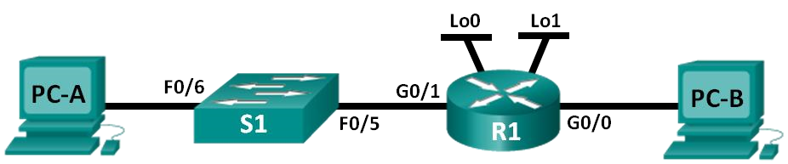

# Addressing Table



|  |  |  |  |  |
| --- | --- | --- | --- | --- |
| **Device** | **Interface** | **IP Address** | **Subnet Mask** | **Default Gateway** |
| R1 | G0/0 | 192.168.0.97 | 255.255.255.224 | N/A |
|  | G0/1 | 192.168.0.1 | 255.255.255.224 | N/A |
|  | Lo0 | 192.168.0.33 | 255.255.255.224 | N/A |
|  | Lo1 | 192.168.0.65 | 255.255.255.224 | N/A |
| S1 | VLAN 1 | 192.168.0.2 | 255.255.255.224 | 192.168.0.1 |
| PC-A | NIC | 192.168.0.4 | 255.255.255.224 | 192.168.0.1 |
| PC-B | NIC | 192.168.0.100 | 255.255.255.224 | 192.168.0.97 |

# Objectives

**Part 1: Design a Network Subnetting Scheme**

**Part 2: Configure the Devices**

**Part 3: Test and Troubleshoot the Network**

**Note: Please complete the two other workshop activities prior to Attempting this Lb. The second activity walks through a scenario similar in nature to what is required in this Lab.**

# Background / Scenario

In this lab, starting from a single network address and network mask, you will subnet the network into multiple subnets. The subnet scheme should be based on the number of host computers required in each subnet, as well as other network considerations, like future network host expansion.

After you have created a subnetting scheme and completed the network diagram by filling in the host and interface IP addresses, you will configure the host PCs and router interfaces, including loopback interfaces. The loopback interfaces are created to simulate additional LANs attached to router R1.

After the network devices and host PCs have been configured, you will use the **ping** command to test for network connectivity.

and/or its affiliates. All rights reserved.

**Step 1: Create a subnetting scheme that meets the required number of subnets and required number of host addresses.**

In this scenario, you are a network administrator for a small subdivision within a larger company. You must create multiple subnets out of the 192.168.0.0/24 network address space to meet the following requirements:

* The first subnet is the employee network. You need a minimum of 25 host IP addresses.
* The second subnet is the administration network. You need a minimum of 10 IP addresses.
* The third and fourth subnets are reserved as virtual networks on virtual router interfaces, loopback 0 and loopback 1. These virtual router interfaces simulate LANs attached to R1.
* You also need two additional unused subnets for future network expansion.

**Note**: Variable length subnet masks will not be used. All of the device subnet masks will be the same length.

**Preparation:**

Answer the following questions to help create a subnetting scheme that meets the stated network requirements:

* 1. How many host addresses are needed in the largest required subnet? **25**
  2. What is the minimum number of subnets required? **6**
  3. The network that you are tasked to subnet is 192.168.0.0/24. What is the /24 subnet mask in binary?

**11111111.11111111.11111111.00000000**

* 1. The subnet mask is made up of two portions, the network portion, and the host portion. This is represented in the binary by the ones and the zeros in the subnet mask.

In the network mask, what do the ones represent? **Network portion-------------------------------------------**

In the network mask, what do the zeros represent? **Host Portion-----------------------------------------------**

* 1. To subnet a network, bits from the host portion of the original network mask are changed into subnet bits. The number of subnet bits defines the number of subnets. Given each of the possible subnet masks depicted in the following binary format, how many subnets and how many hosts are created in each example?

**Hint**: Remember that the number of host bits (to the power of 2) defines the number of hosts per subnet (minus 2), and the number of subnet bits (to the power of two) defines the number of subnets. The subnet bits (depicted in bold type face) are the bits that have been borrowed beyond the original network mask of /24. The /24 is the slash prefix notation and corresponds to a dotted decimal mask of 255.255.255.0.

## (/25) 11111111.11111111.11111111.**1**0000000

Dotted decimal subnet mask equivalent: ________________________________

Number of subnets? ________________, Number of hosts? ________________ (/26) 11111111.11111111.11111111.**11**000000

Dotted decimal subnet mask equivalent: ________________________________

Number of subnets? ________________, Number of hosts? ________________ (/27) 11111111.11111111.11111111.**111**00000

Dotted decimal subnet mask equivalent: 255.255.255.224

Number of subnets? **8** Number of hosts? **32-2 = 30**

(/28) 11111111.11111111.11111111.**1111**0000

Dotted decimal subnet mask equivalent: ________________________________

Number of subnets? ________________ Number of hosts? _________________ (/29) 11111111.11111111.11111111.**11111**000

Dotted decimal subnet mask equivalent: ________________________________

Number of subnets? ________________ Number of hosts? _________________ (/30) 11111111.11111111.11111111.**111111**00

Dotted decimal subnet mask equivalent: ________________________________

Number of subnets? ________________ Number of hosts? _________________

6) Considering your answers, which subnet masks meet the required number of minimum host addresses?

__________________________________________________________________________

7) Considering your answers, which subnet masks meets the minimum number of subnets required?

________________________________________________________________________________

1. Considering your answers, which subnet mask meets both the required minimum number of hosts and the minimum number of subnets required?

/27_____________________________________________________________________________

1. When you have determined which subnet mask meets all of the stated network requirements, you will derive each of the subnets starting from the original network address. List the subnets from first to last below. Remember that the first subnet is 192.168.0.0 with the newly acquired subnet mask.

|  |  |  |
| --- | --- | --- |
| **Subnet Address / Prefix Subnet Mask (dotted decimal)** | | |
| 192.168.0.0 / | 27 | __________________________ |
| 192.168.0.32 / | 27 | __________________________ |
| 192.168.0.64 / | 27 | __________________________ |
| 192.168.0.96 / | 27 | __________________________ |
| 192.168.0.128 / | 27 | __________________________ |
| 192.168.0.160 / | 27 | __________________________ |
| 192.168.0.192 / | 27 | __________________________ |
| 192.168.0.224 / | 27 | __________________________ |

**Step 2: Complete the diagram showing where the host IP addresses will be applied**

On the following lines provided in the diagram below, fill in the IP addresses and subnets masks in slash prefix notation.

On the router, configure the subnet information so that:

G0/1 is the first subnet

Loopback 0 (Lo0) is the second subnet Loopback 1 (Lo1) is the third subnet G0/0 is the fourth subnet.

For G0/1, Loopback 0, Loopback 1, and G0/0, use the first usable address in their subnet for the router interface.

For PC-A use the 3rd usable address on its network.

For PC-B use the 4th usable address on its network.

For the S1 Vlan1 use the second usable address on its network.

Also enter this information into the Addressing Table on Page 1.

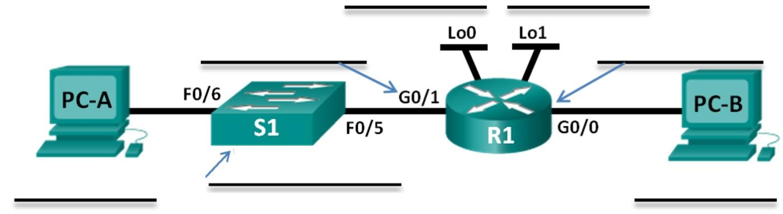

 **Configure the Devices**

In Part 2, set up the network topology and configure settings on the PCs, Switch and router, such as the router Gigabit Ethernet interface IP addresses, and the PC’s IP addresses, subnet masks, and default gateways. Refer to the Addressing Table for device names and address information:

1. Fully configure the switch as per the standard configuration steps discussed in previous labs and save the configuration:
   1. Correct device names as per the topology
   2. DNS lookup turned off
   3. IP address as listed in Addressing Table 4) Configure the default gateway for the Switch 5) Clear text passwords encrypted.
   4. **cisco** as the console and vty passwords with login and logging synchronous enabled
   5. **class** as the privileged EXEC password
   6. Banner that warns anyone accessing the device that unauthorized access is prohibited. With the following text:

**Unauthorised access is prohibited and will be prosecuted strictly.**

1. Configure the router:

Configure the routers as per the standard configuration in previous labs:

* 1. Assign a device name to the router.
  2. Disable DNS lookup to prevent the router from attempting to translate incorrectly entered commands as though they were host names.
  3. Assign **class** as the privileged EXEC encrypted password.
  4. Assign **cisco** as the console password and enable login and synchronous logging.
  5. Assign **cisco** as the VTY password and enable login and synchronous logging. Verify the number of vty lines are on the router.
  6. Encrypt the clear text passwords.
  7. Create a banner that warns anyone accessing the device:

**Unauthorised access is prohibited and you will be strictly prosecuted.**

* 1. Assign *IPv4* addresses to all 4 interfaces on Router as per the addressing table and enable them.

interface g0/0 interface g0/1 interface loopback 0 interface loopback 1

**Note:** Loopback interfaces are created to simulate additional LANs on R1 router. Configure the loopback interfaces with their IP address and subnet mask. After they are created, loopback interfaces are enabled, by default.

To create the loopback addresses, enter the command **interface loopback 0** at the global config mode and enter the IPv4 address and subnet mask as for a normal interface.

**Example:**

R1(config)# **interface lo0**

R1(config-if)# **ip address [ip address] [subnet mask]**

R1(config-if)# **no shutdown**

R1(config-if)# **exit**

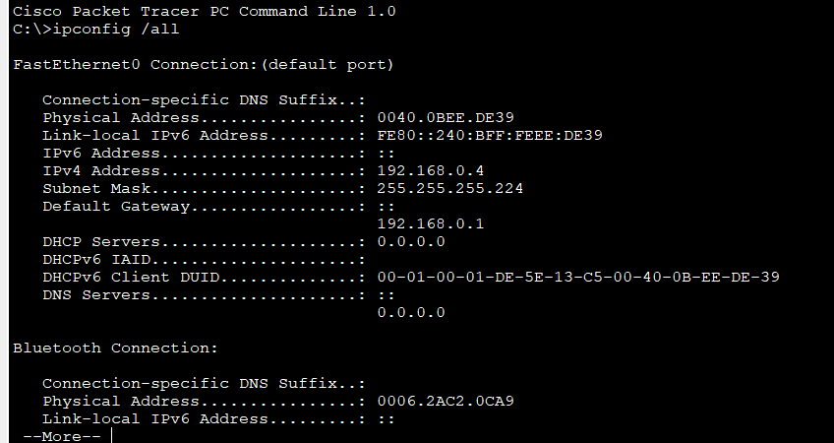

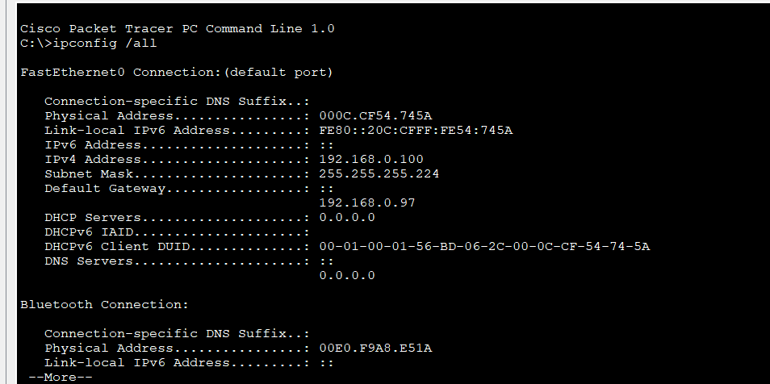

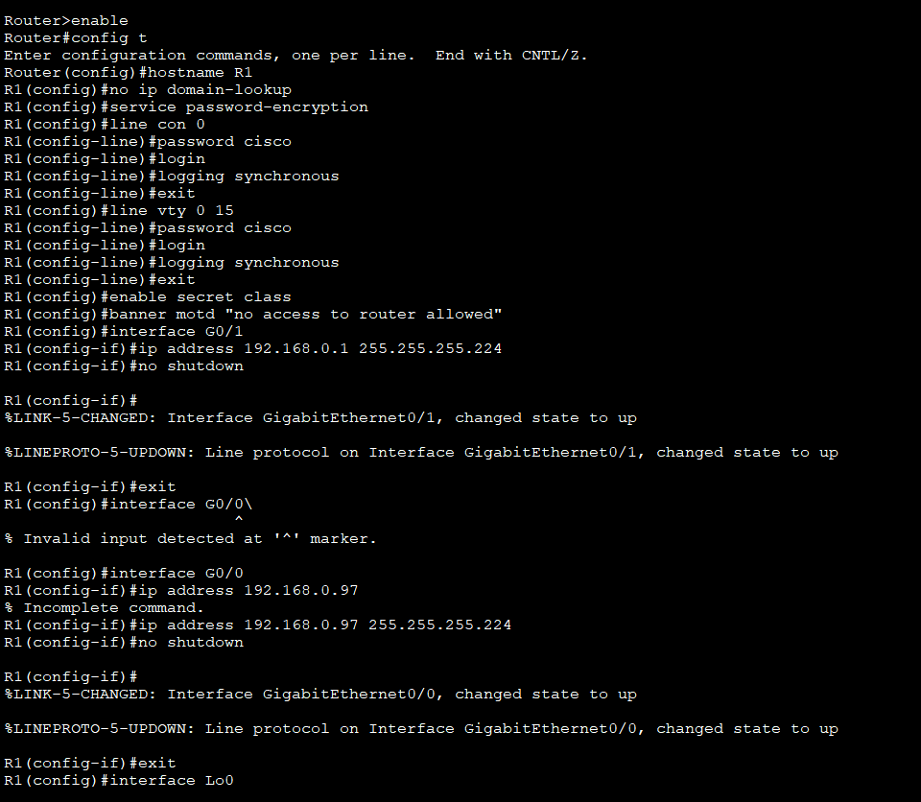

**Step 2: Configure the PC interfaces.**

1. Configure the IP address, subnet mask, and default gateway settings on PC-A.
2. Configure the IP address, subnet mask, and default gateway settings on PC-B.

 **Test and Troubleshoot the Network:**

In Part 3, you will use the **ping** command to test network connectivity.

1. Test to see if PC-A can communicate with its default gateway. From PC-A, open a command prompt and ping the IP address of the router Gigabit Ethernet 0/1 interface. Do you get a reply? **Yes**
2. Test to see if PC-B can communicate with its default gateway. From PC-B, open a command prompt and ping the IP address of the router Gigabit Ethernet 0/0 interface. Do you get a reply? **Yes**
3. Test to see if PC-A can communicate with PC-B. From PC-A, open a command prompt and ping the IP address of PC-B. Do you get a reply? **Yes**
4. Test to see if PC-B can communicate with PC-A. From PC-B, open a command prompt and ping the IP address of PC-A. Do you get a reply? **Yes**
5. Test to see if PC-A can communicate with Loopback 0 on R1. From PC-A, open a command prompt and ping the IP address of Loopback 0. Do you get a reply? **Yes**
6. Test to see if PC-A can communicate with Loopback 1 on R1. From PC-A, open a command prompt and ping the IP address of Loopback 0. Do you get a reply? **Yes**
7. If you answered “no” to any of the preceding questions, then you should go back and check all of your IP address and subnet mask configurations, and ensure that the default gateways have been correctly configured on PC-A and PC-B.
8. Experiment by purposely misconfiguring the gateway address on PC-A to 10.0.0.1. What happens when you try and ping from PC-B to PC-A? Do you receive a reply?

____________________________________________________________________________________

____________________________________________________________________________________

# Reflection

1. Subnetting one larger network into multiple smaller subnetworks allows for greater flexibility and security in network design. However, what do you think some of the drawbacks are when the subnets are limited to being the same size?

_______________________________________________________________________________________

_______________________________________________________________________________________

1. Why do you think the gateway/router IP address is usually the first usable IP address in the network?

_______________________________________________________________________________________